Water ATM with Bottle Dispenser

Plastic bottles and bottle caps make up for over 45% of non degradable waste that is polluting our oceans and land mass. These plastic bottles are made to be recyclable so why do they pollute our water and land ?
Well over 70% of these bottles never make it to the recycling process and ends up in oceans and landfills. Using and disposing a plastic bottle each time a traveler needs to drink 100ml to 1Liter of water is just not sustainable. This system of packaged water satisfies a humans one time thirst and turns up good profit for the company at a huge cost to our environment which cannot sustain this process for long.
Water ATM’s have started to be seen in public places but have 2 major issues.
1. The user dosent always carry a bottle to fill it at a water ATM.
2. The user dosent always carry coins to use the water ATM.
Well here we propose a very sustainable solution to all these problem that allows to serve water to travelers at way cheaper prices and without damaging the environment.
The smart water atm serves water on coin insertion as well as Card scanning. This dosent require user to carry cash while using the ATM. Also the water atm machine has an integrated bottle dispenser that dispenses non disposable water bottles that can be used for over 2-3 Years.
The system is developed using an STM32 controller, coin module, solenoid valve, keypad, rfid scanner and motors to develop the system. This allows for a smart water dispenser machine that can dispense water on demand to users.
The machine when turned on allows user to select amount of water to be filled. User may select amount of water to be filled, once the user selects water quantity, the system displays the cost Rs.1 to Rs.5 for 100 ml to 1 Liter. After selection, system waits for water bottle to be placed in the filling section. The filling wont start until a bottle is detected in the filling panel.
RFID cards are used to demonstrate as monthly pass/card payment and provide desired water quantity on card scan without requiring any coin insertion.
Once a bottle is detected the controller switches on a solenoid pump that drives water into the bottle through pipes. The system uses a flow meter sensor in order to detect the amount of water dispensed. The system now dispenses selected water amount and stops flow.
In case the user does not carry a water bottle, the system also provides bottle dispensing. User can press on bottle using keypad. The user may now choose from 2 bottle capacities, half liter and 1 liter. The user is now asked to scan card (to simulate dummy payment) so that bottle payment can be made.
Based on users choice the system operates the motor which operates the spring mechanism that pushes the bottle forward into dispensing panel. Once dispensed the bottle may be collected by user for filling at ATM.

Components
- Stm32 Controller
- LCD Display
- Keypad
- Coin Module
- RFID Scanner
- Flow Sensor
- Electric Valve Pump
- Spring Coils
- LED’s
- PCB Board
- Resistors
- Capacitors
- Transistors
- Cables and Connectors
- Machine Body Frame

Block Diagram
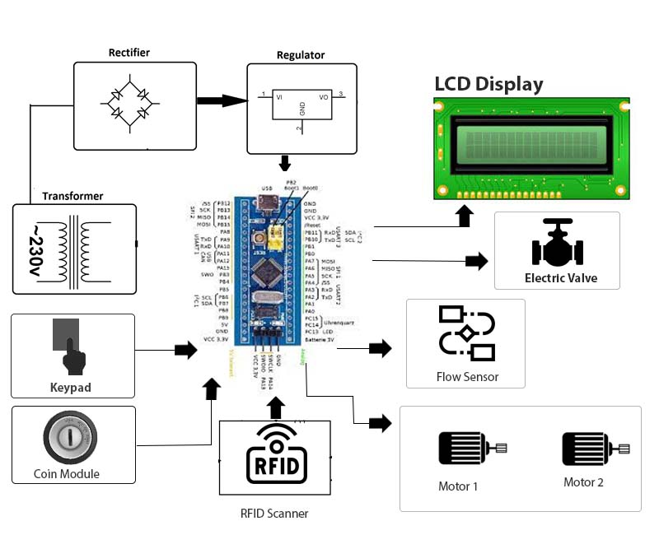

Block Diagrams
